**Using Coordinates to Move a Graphic**

Before you begin, make sure that you understand how the [coordinate system works on a Form](https://sites.google.com/gotvdsb.ca/aldworth/home/ics-2o/advanced-programming/coordinate-system-in-vb):

<https://sites.google.com/gotvdsb.ca/aldworth/home/ics-2o/intro-to-programming/coordinate-system-in-vb>

Make sure you have completed the [Keyboard Events tutorial](https://sites.google.com/gotvdsb.ca/aldworth/home/ics-2o/advanced-programming/keyboard-events):

<https://sites.google.com/gotvdsb.ca/aldworth/home/ics-2o/advanced-programming/keyboard-events>

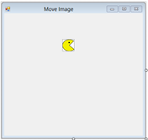**Part 1 - Create your Project**

We will start by creating a new project named **Move Image**.

Create the following interface, it only has one PictureBox to begin:

Name the controls: **frmMoveImage imgPacMan**

Create an integer variable called **intSpeed** at the top of your program, and set it to 5 in the Form Load event.

Add the four Pac-Man images provided in the Images folder (or any images of your choice) into the Project Resources. These will represent your moving character in different directions. Set the image of imgPacMan to one of the Pac-Man pictures from resources and set its **Sizemode** property to **Stretched**.

We are going to add our movement code to the **KeyDown** event for our Form. We are going to put our movement code in the KeyDown event.

**Part 2 - Moving the Character and the Coordinate System**

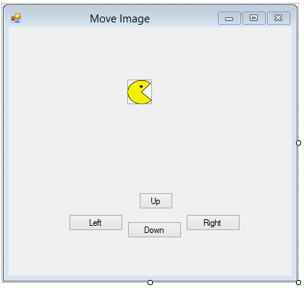

PictureBox controls (and many other controls) have a **Location (x, y),**

**Left**, **Right**, **Top** and **Bottom** properties that allow us to get the x and

Y coordinates of any side or edge of our PictureBox.

Because the upper-left portion of an application window

tends to be fixed, this is where the origin coordinate (0, 0)

is. The x-coordinates increase as you move right, and the

y-coordinates increase as you move down.

Add the following lines of code to the **KeyDown** event handler:

‘**e**’ stores information regarding the event that triggered the KeyDown handler. We can use an **If** statement to determine which key is pressed. down.

Keys.Right refers to the right arrow key.

If e.KeyCode = Keys.Right Then

imgPacMan.Left += intSpeed

End If

*Run your program and test right arrow!*

Here we add **intSpeed** which has a value of 5 to the **Left** property (x-coordinate of the left side) of our PictureBox.

**Moving in All Directions**

Add code to the KeyDown event for the remaining directional arrows (Keys.Left, Keys.Up, Keys.Down) by adding **ElseIf** statements to the **If** statement we just added for the right arrow key.

**Move Left*:*** instead of adding **intSpeed** to the **Left** property (x-coordinate) as we did to move right, subtract it to move left. imgPacMan.Left -= intSpeed

**Moving Up:** to move our PictureBox upwards, we must subtract **intSpeed** from the **Top** property (y-coordinate) because y-values increase as you move downwards on a Form.

…

ElseIf e.KeyCode = Keys.Up Then

imgPacMan.Top -= intSpeed

End If

We can directly change the **Top** and **Left** property of a PictureBox. The **Right** and **Bottom** properties are **read only**.

**Moving Down:**  try this on your own.

*Run your Program.* What happens when PacMan reaches the edge of your Form?

**Things to try:**

* Experiment with the speed at which your character moves. Can the user change the speed?
* We have four different images of Pac Man in the program resources. Change the **Image** property of imgPacMan to display a picture of Pac Man facing in the direction that he is travelling.
* Add two more ElseIf statements to KeyDown to grow or shrink imgPacMan by changing the **Size** property of your PictureBox. You decide how much.

Hints:

* + imgPacMan.Width and imgPacMan.Length will give you the current width and height.
  + Use ‘**new Size(width, height)**’ to change the size of a PictureBox:

imgPacMan.Size = new Size(________, _______)

* + If your PictureBox is not a perfect square you will want to use a multiplier, or a ratio of the sides in order to get it to grow proportionally.
* Allow the user to restart PacMan at an origin point with the press of a key.
  + We can also change the Location property of out PictureBox by creating a new Point. This would be handy for transporting it somewhere.
  + If you wanted to move the PictureBox to the origin, you could use this line of code for a specific key:

imgPacMan.Location = new Point(0, 0)

* Instead of the origin, have PacMan move to a random location on the Form.

There are multiple ways to change the location of your PictureBox. Which method you use is entirely up to you.

**imgPacMan.Left += intspeed**

All three produce the same result.

**imgPacMan.Location = new Point(imgPacMan.Location.X + intSpeed, imgPacMan.Location.Y)**

**imgPacMan.Location = new Point(imgPacMan.Left + intSpeed, imgPacMan.Top)**

**Part 3 - How do I Keep my Character from Running off my Form?**

It is important to first understand how we can get the x and y vaules of the top, bottom, left and right sides of our PictureBox. The x and y coordinates of the **Location** property of our PictureBox (and all controls) are its upper left corner. Each control also has a **Width** and **Height** property. We can do some simple math to figure out the x value of the right side of our PictureBox, and the y value of the bottom of our PictureBox.

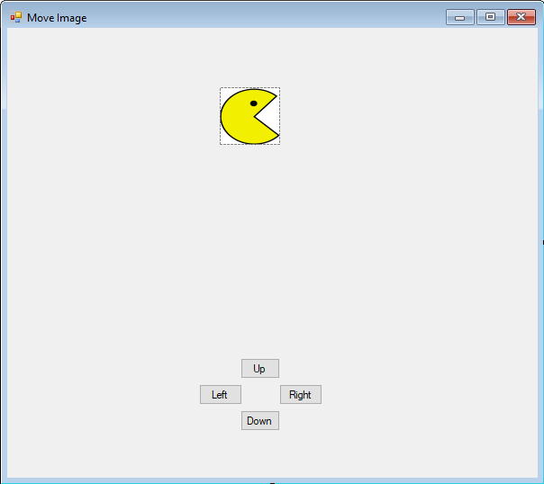

1

**(**imgPacMan.Location.X, imgPacMan.Location.y**)**

imgPacMan.Width

3

2

imgPacMan.Width

**X Value of the right side of our PictureBox**: add the width to the x-value of the Location property.

imgPacMan.Location.X + imgPacMan.Width **OR**  imgPacMan.Right

**Y-Value of the bottom of our PictureBox**: add the height to the y-value of the Location property

imgPacMan.Location.Y + imgPacMan.Height **OR**  imgPacMan.Bottom

An unfortunate consequence with moving a PictureBox is that it is redrawn on the Form immediately after you change its Location property. We don’t get to move it, and decide that its in a bad spot and move it back before it is drawn. This means that before we move it, we need to predict where it will be, and use that predicted location to determine whether it is in a good spot.

**Make sure we are moving to a place on the Form.**

Each time we want to change the Location property of our imgPacMan, we should test to see if its **future** Location will cause any part of it to be outside of our Form before we actually move it. We do not want to move it off our Form only to move it back again. This will cause jittery movement at the bounds of our Form.

**Left Side**

Making sure that our PictureBox does not move off the left side of our Form is relatively straightforward. We just need to make sure that after we subtract intSpeed from its current x value, that it is not less than zero (the left edge of the Form).

We will use this variable to tell us whether we are able to apply a normal movement by intSpeed later.

Add the following code to the **Keys.Left** if statement:

Dim bolSafeMove as Boolean = True

If the move will put imgPacMan partially off the Form, set it right against the left edge instead by making its x-value 0.

Future x coordinate.



If imgPacMan.Left - intSpeed < 0 Then

imgPacMan.Left = 0

bolSafeMove = False

End If

This tells us that we were not able to move by intSpeed.

If bolSafeMove Then

imgPacMan.Left -= intSpeed

End If

This is done if we didn’t detect a movement off the Form earlier.

**Right Side**

Making sure we do not go off the right side of the Form is a bit more complicated because we can only change the Left property of imgPacMan. To find the x-value that we want to set imgPacMan.Left to we subtract imgPacMan’s width from the edge of the Form.

Add the following code to the **Keys.Right** if statement:

**imgPacMan.Right** (read only) will give us the x-value of the right side of imgPacMan.

**Me.ClientSize.Width** is the width of the Form (also the x-value of the right edge of your Form).

Dim bolSafeMove as Boolean = True

If imgPacMan.Right + intSpeed > Me.ClientSize.Width Then

imgPacMan.Left = Me.ClientSize.Width - imgPacMan.Width

bolSafeMove = False

imgPacMan.Width

End If

If part of our Picturebox will go off the edge of the Form when we move it, we can place it at the edge instead.

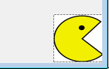

If bolSafeMove Then

imgPacMan.Left += intSpeed

End If

X value of right edge of Form = Me.ClientSize.Width

**Things to try:**

* What effect does changing **intSpeed** have on your program?
* How could you to allow the user the ability to change the speed of imgPacMan themselves (directly or indirectly)? Try it.
* Use a similar idea as left and right to keep imgPacMan from leaving the **top** or **bottom** of your Form (you will be using the **Top** and **Bottom** properties of imgPacMan along with the **Height** property).
* Put in a background image. Your program will be more efficient if you make the BackgroundImage property of the Form contain the image instead of using a PictureBox. Use image editing software to make the size of the background image be the same as your Form’s ClientSize before importing it into your program. You do not want to force your program to re-size images each time the Form is updated.
* Remove (or comment out) the checks that prevent imgPacMan from leaving the confines of the Form. When the player moves imgPacMan off the edge of the Form, have imgPacMan re-enter the Form from the opposite side (or a random side).
* Use a String variable to keep track of the direction Pac-Man is facing. Add an **If** statement to each direction so that the Image property of imgPacMan only changes when PacMan changes direction. This will save your program from re-loading an image into imgPacMan each time a Button is clicked and only do it when the picture needs to be changed to face a new direction.

**Part 4 - Collision Detection**

**Important information:**

In order to detect collisions, we are going to use a function called IntersectsWith(). This function will take two rectangles, and tell you if they intersect. The rectangles that IntersectsWith() compares consist of a single coordinate (upper left) and a width and height. There is a property of PictureBoxes (along with most other controls) called **Bounds** that is such a rectangle.

imgPacMan.Bounds

We can get the bounding rectangle of imgPacMan using this line of code:

**How can we have our character eat a cookie?**

Create a PictureBox and name it **imgCookie**. Find the image of a cookie, and add it to the resources and then put that image into **imgCookie**.

Each time we move our character, we need to check to see if we collided with our cookie. Do this with the following code in your KeyDown event (**after** you have already moved imgPacMan):

'Checks for collision with cookie

If imgPacMan.Bounds.IntersectsWith(imgCookie.Bounds) Then

imgCookie.Visible = False

End If

This will return **True** if the rectangles that make up the boundaries of the two PictureBoxes touch.

Try **Contains()**, instead of **IntersectsWith()** for this check. What effect does this change have?

**How can I have an obstacle block my character?**

Create a Picturebox and name it **imgRock**. Find the image of a rock, and add it to the resources and then put that image into **imgRock**.

Each time we want to move our character, we need to check to see if we will collide with an obstacle before we actually move. If we detect a future collision, we will place the edges of our two PictureBoxes boxes next to one another instead of overlapping.

To do this, we will make a virtual Rectangle that will be in the location that we intend on moving imgPacMan to. We will call this virtual Rectangle **tempRect**.

To make a virtual Rectangle, we need an **(x, y) coordinate** of the top left, and a **width** and **height**.

**Moving Right**

Add the following lines of code to the beginning of the **Keys.Right** if statement:

Dim tempRect As Rectangle

tempRect = New Rectangle(imgPacMan.Location.X + intSpeed, imgPacMan.Location.Y, imgPacMan.Width, imgPacMan.Height)

All other properties of imgPacMan should remain the same.

Apply the move to the x-coordinate to move imgPacMan to the right.

Now that we have a Rectangle that can represent where imgPacMan will be after moving him, we can use this Rectangle to check for collisions.

We need to add a separate **If** statement to Keys.Right. We can put this check just after we check to see if imgPacMan moves off the edge of our Form.

'Checks for collision with obstacle

If tempRect.IntersectsWith(imgRock.Bounds) Then

imgPacMan.Left = imgRock.Left - imgPacMan.Width

bolSafeMove = False

End If

imgRock.Left

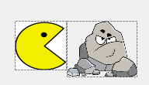

We want the right side of imgPacMan to rest against the left side of the obstacle. That means that imgPacMan’s x-value should be exactly its width away from imgRock’s x-value.

imgPacMan.Width

**Moving Left**

We essentially do the same thing, except if we detect a collision, we will set imgPacMans left edge against the right side of imgRock.

Create our temporary rectangle:

Dim tempRect As Rectangle

tempRect = New Rectangle(imgPacMan.Location.X - intSpeed, imgPacMan.Location.Y, imgPacMan.Width, imgPacMan.Height)

We now can add our test for a collision:

If tempRect.intersectsWith(imgRock.Bounds) Then

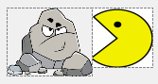 imgPacMan.Left = imgRock.Right

bolSafeMove = False

End If

**Moving Up and Down**

Use the same idea as above except for up and down so PacMan will not collide with any side of the obstacle.

**Things to try**

* When your character eats the cookie, instead of making it invisible, change the image to crumbs
* Add multiple ‘edible’ objects
  + If you want different effects from a collision with different objects, you will need separate If statements for each edible object
* Add a ‘Portal’ that will ‘transport’ PacMan to a different Location on your Form. Try to use the Contains() method for collision detection instead of IntersectsWith()
* Add a second rock (don’t add more than two though, there is an easier way)
* Change the players speed/size/image/behavior in some way when an object is consumed
* Use WASD instead of arrow keys
* Add a second controllable character that moves with different keys than imgPacMan

**Part 5 – Multiple Collisions**

The above methods work for detecting collisions with a small number of objects but it does not scale well. For example, if you had ten walls, would you want to type out ten If statements? What about fifty walls?

The solution to that is to put items that have similar behaviors into groups called Lists. For example, PacMan should interact with all impassible objects in the same way, so we can group all of our rocks together. He likely would interact with multiple cookies in the same way.

**Creating a List of Rocks**

Add the following line of code to the top of your program:

Dim Rocks As List(Of PictureBox)

We are going to add all of the **PictureBoxes** that are rock obstacles to this list.

**Make Rocks and Add them to List**

Create 2 more PictureBoxes, name them **imgRock2** and **imgRock3**, and set their image property to a rock. You can save time by copying and pasting the first rock PictureBox you made. Just make sure you change the Name property.

To add the three rocks to your List, add the following code to your Form Load event.

Rocks.Add(imgRock)

Rocks.Add(imgRock2)

Rocks.Add(imgRock3)

We now can iterate through our collection Rocks to detect collisions.

**Use a Loop to Iterate Through a Collection**

Since we want the effect of bumping into a wall to be the same no matter what wall we hit, we can use pretty much the same code as before. All we need to do it all a loop.

**Step 1** - Add the following code just before your collision check with imgRock.

We can use the generic name ‘rock’ to refer to each item in our collection.

For Each rock In Rocks

The code that we put inside this For…Each loop will be executed for each rock that we added to our list of rocks.

Next

**Step 2** - Cut and paste the entire If statement check that contained our collision detection with the rock into this For..Each loop:

For Each rock In Rocks

If tempRect.IntersectsWith(imgRock.Bounds) Then

imgPacMan.Left = imgRock.Left - imgPacMan.Width

bolSafeMove = False 'Indicates that a normal move by intSpeed should not be done

End If

Next

**Step 3** – Change each instance of **imgRock** to **rock** in the code:

For Each rock In Rocks

If tempRect.IntersectsWith(rock.Bounds) Then

imgPacMan.Left = rock.Left - imgPacMan.Width

bolSafeMove = False 'Indicates that a normal move by intSpeed should not be done

End If

Next

This needs to be done because each time our loop moves onto the next item in our collection, it will be stored in a generic variable named ‘rock’ so that we can refer to it without using its Name property.

Add a For…Each loop to the remaining directional movements.

**Mini Project**

Create a mini maze game with your own characters and graphics. Add some interesting features such as:

* Have a finish line unlocked by a key that must be eaten
* Present some type of victory screen upon completion
* Have walls that change location to block or unblock sections when certain power-ups are consumed
* Have hazards that cause the player to ‘die’
* Add a transporter/portal
* Add a health mechanic
* Any other interesting ideas